PART 1:
using System;
using System.Collections.Generic;
using System.Linq;
using System.Text;
using System.Threading.Tasks;

namespace ConsoleRegisterStudent
{
class Program
{
static void Main(string[] args)
{
(new Program()).run();
}

void run()
{
int choice;
int firstChoice = 0, secondChoice = 0, thirdChoice = 0;
int totalCredit = 0;
string yesOrNo = "";

System.Console.WriteLine("Lloyd's Copy");

do
{
WritePrompt();
choice = Convert.ToInt32(Console.ReadLine());

switch (ValidateChoice(choice, firstChoice, secondChoice, thirdChoice, totalCredit))
{
case -1:
Console.WriteLine("Your entered selection {0} is not a recognized course.", choice);
break;
case -2:
Console.WriteLine("You have already registered for this {0} course.", ChoiceToCourse(choice));
break;
case -3:
Console.WriteLine("You can not register for more than 9 credit hours.");
break;
case 0:
Console.WriteLine("Registration Confirmed for course {0}.", ChoiceToCourse(choice));
totalCredit += 3;
if (firstChoice == 0)
firstChoice = choice;
else if (secondChoice == 0)
secondChoice = choice;
else if (thirdChoice == 0)
thirdChoice = choice;
break;
}

WriteCurrentRegistration(firstChoice, secondChoice, thirdChoice);
Console.Write("\nDo you want to try again? (Y|N)? : ");
yesOrNo = (Console.ReadLine()).ToUpper();
} while (yesOrNo == "Y");

Console.WriteLine("Thank you for registering with us");
}

void WritePrompt()
{
Console.WriteLine("Please select a course for which you want to register by typing the number inside []");
Console.WriteLine("[1]IT 145\n[2]IT 200\n[3]IT 201\n[4]IT 270\n[5]IT 315\n[6]IT 328\n[7]IT 330");
Console.Write("Enter your choice : ");
}

int ValidateChoice(int choice, int firstChoice, int secondChoice, int thirdChoice, int totalCredit)
{
if (choice < 1 || choice > 7)
return -1;
else if (choice == firstChoice || choice == secondChoice || choice == thirdChoice)
return -2;
else if (totalCredit + 3 > 9)
return -3;
return 0;
}

void WriteCurrentRegistration(int firstChoice, int secondChoice, int thirdChoice)
{
if (secondChoice == 0)
Console.WriteLine("You are currently registered for {0}", ChoiceToCourse(firstChoice));
else if (thirdChoice == 0)
Console.WriteLine("You are currently registered for {0}, {1}", ChoiceToCourse(firstChoice), ChoiceToCourse(secondChoice));
else
Console.WriteLine("You are currently registered for {0}, {1}, {2}", ChoiceToCourse(firstChoice), ChoiceToCourse(secondChoice), ChoiceToCourse(thirdChoice));
}

string ChoiceToCourse(int choice)
{
string course = "";
switch (choice)
{
case 1:
course = "IT 145";
break;
case 2:
course = "IT 200";
break;
case 3:
course = "IT 201";
break;
case 4:
course = "IT 270";
break;
case 5:
course = "IT 315";
break;
case 6:
course = "IT 328";
break;
case 7:
course = "IT 330";
break;
default:
break;
}
return course;
}
}
}
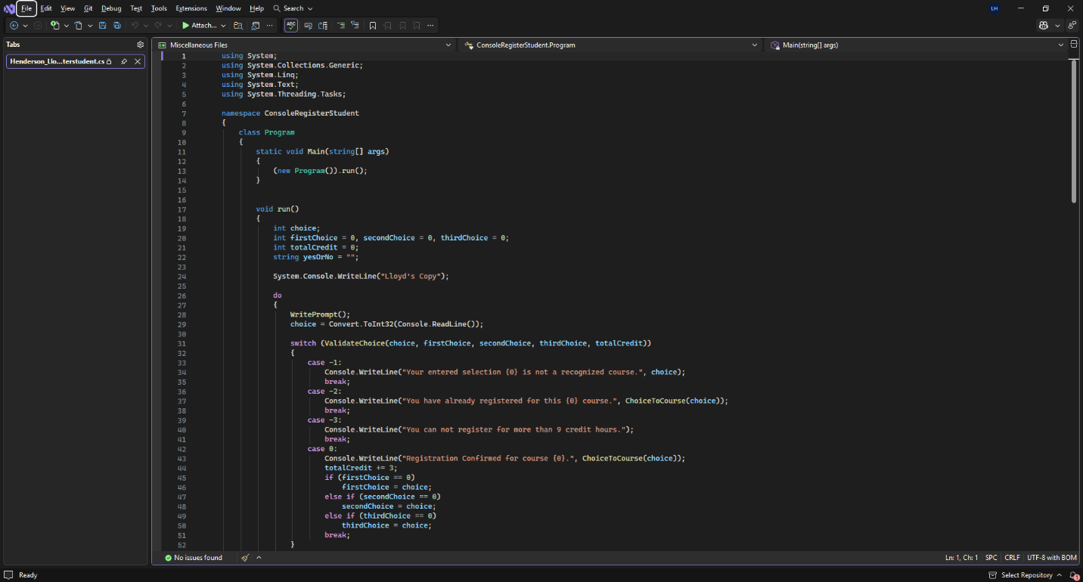
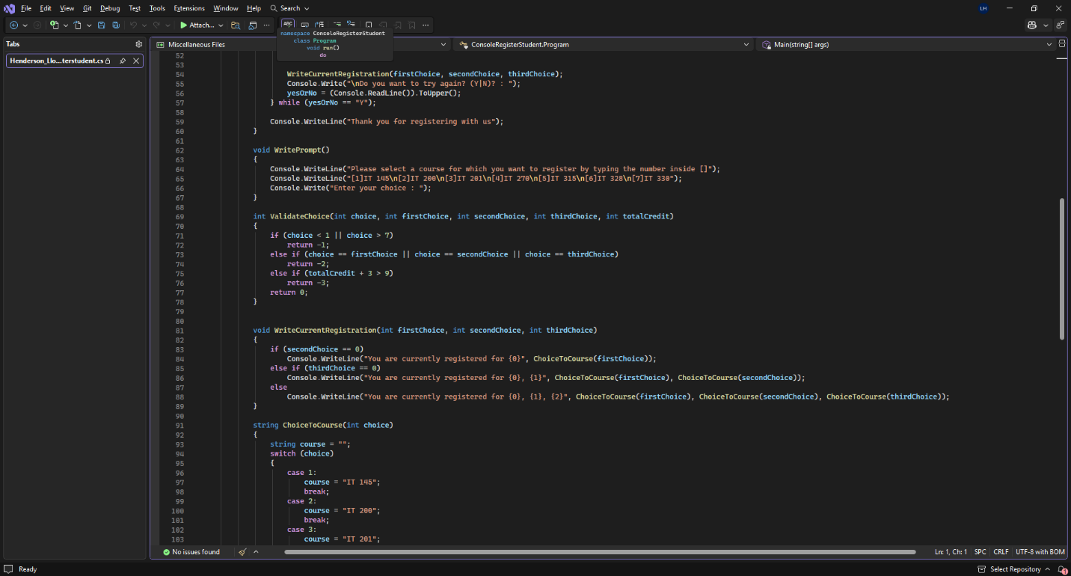
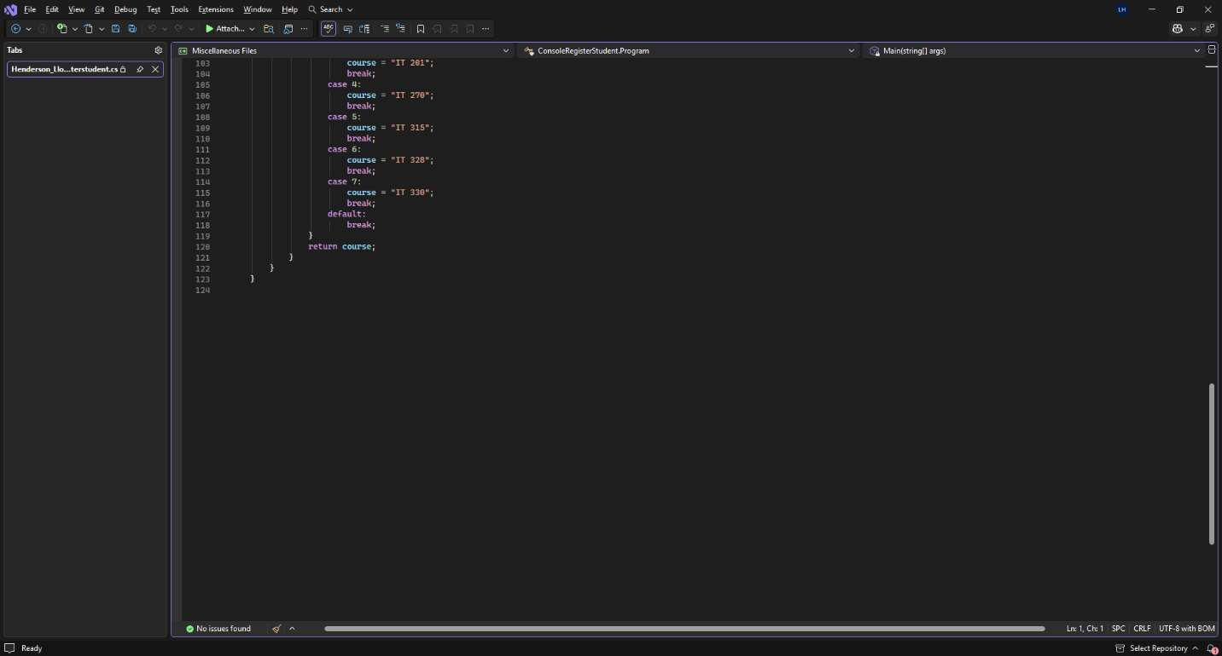
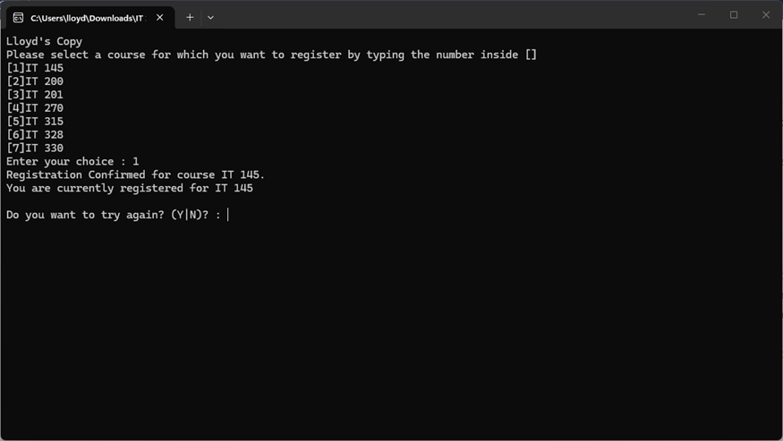

PART 2:
using System;
using System.Collections.Generic;
using System.Linq;
using System.Text;
using System.Threading.Tasks;
using System.Windows;
using System.Windows.Controls;
using System.Windows.Data;
using System.Windows.Documents;
using System.Windows.Input;
using System.Windows.Media;
using System.Windows.Media.Imaging;
using System.Windows.Navigation;
using System.Windows.Shapes;

namespace WPFRegisterStudent
{
/// <summary>
/// Interaction logic for MainWindow.xaml
/// </summary>
public partial class MainWindow : Window

{
Course choice;

public MainWindow()
{
InitializeComponent();
}

private void Window_Loaded(object sender, RoutedEventArgs e)
{

Course course1 = new Course("IT 145");
Course course2 = new Course("IT 200");
Course course3 = new Course("IT 201");
Course course4 = new Course("IT 270");
Course course5 = new Course("IT 315");
Course course6 = new Course("IT 328");
Course course7 = new Course("IT 330");

this.comboBox.Items.Add(course1);
this.comboBox.Items.Add(course2);
this.comboBox.Items.Add(course3);
this.comboBox.Items.Add(course4);
this.comboBox.Items.Add(course5);
this.comboBox.Items.Add(course6);
this.comboBox.Items.Add(course7);

this.textBox.Text = "";
}

private int totalCreditHours = 0;
private const int CreditHoursPerCourse = 3;

private void button_Click(object sender, RoutedEventArgs e)

{
// Get selected course
choice = (Course)this.comboBox.SelectedItem;

// Validate selection
if (choice == null)
{
textBox.Text = "Error: Please select a course.";
return;
}

// Check if already registered
if (choice.IsRegisteredAlready())
{
textBox.Text = $"Error: You are already registered for {choice.getName()}.";
return;
}

// Check credit limit
if (totalCreditHours + CreditHoursPerCourse > 9)
{
textBox.Text = "Error: You cannot register for more than 9 credit hours.";
return;
}

// Register the course
choice.SetToRegistered();
totalCreditHours += CreditHoursPerCourse;

// Build list of registered courses
string registeredList = "";
foreach (Course c in comboBox.Items)
{
if (c.IsRegisteredAlready())
{
registeredList += c.getName() + " ";
}
}

// Display confirmation
textBox.Text =
$"Registration successful!\n" +
$"You registered for: {choice.getName()}\n\n" +
$"Current Courses: {registeredList}\n" +
$"Total Credit Hours: {totalCreditHours}";

TotalHoursTextBox.Text = totalCreditHours.ToString();

}
}
}
